Information for Health Professionals
When doing Advance Care Planning, many people will appoint or identify their MTDM and then speak with them about what is important.
Verbal Advance Care Planning must be considered in treatment planning, along with written information.
Even with written or verbal Advance Care Planning, it may not be clear to a worried or tired MTDM about how to make the best decision for the person they represent. The Clinicians must facilitate the decision-making, helping the MTDM recognise what they know about the person and how to apply it to the decision at hand.
Do not ask what the MTDM and family want.
The correct question is:
“What would the person want for themselves?”

The Clinician may need to remind the MTDM that they must do what they believe the person would and not do what they or the family would want. This can be hard when the MTDM and family are facing a person dying. The desire to try and keep someone they love alive may be overwhelming, but it would be the wrong thing to do (legally and ethically) if the patient doesn’t want that treatment.

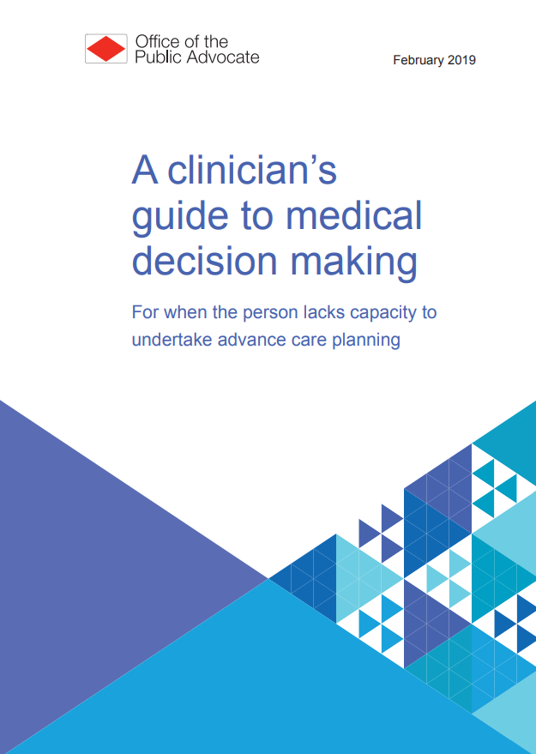
A clinician’s guide to medical decision making for when the person lacks capacity to undertake advance care planning (publicadvocate.vic.gov.au)

