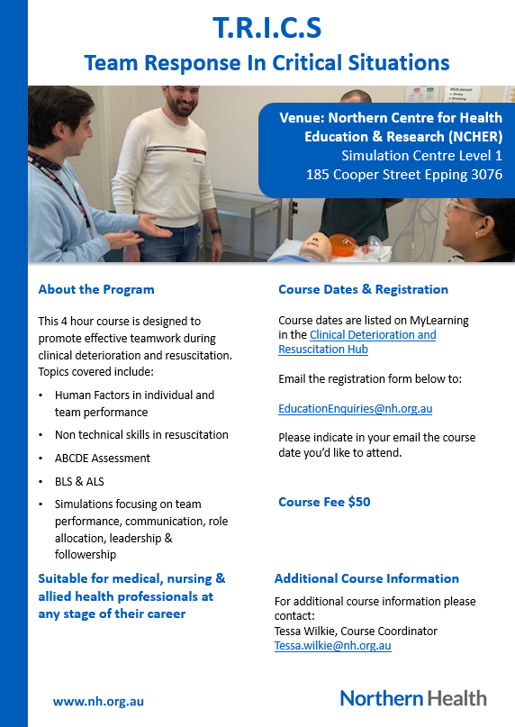

.

Registration
Complete this form and return it to EducationEnquiries@nh.org.au

Applicant Name: Enter here | Employee Number: Enter here
Email address: Enter here | Mobile Number: Enter here
Discipline: Nursing ☒ Medical ☐ Other (please specify) ☐  Enter here | Previous training (tick all that apply):  ☐ BLS ☐ ARC ALS 2  ☐ ALS ☐ APLS  ☐ ARC ALS 1
Specialty (e.g Emergency, Surgical, Medical):
Enter here

Payment Details:
VISA ☐ | MASTERCARD ☐ |  | CHEQUE ☐
CARD NUMBER |  | AMOUNT: $50.00  Expiry Date: Enter date  CCV number: Enter here
Card holder name: Enter here  Signature: Enter here |  | Date: Enter here

Terms & Conditions
- All fields must be completed
- No cash payments accepted
- Payments will be processed after the registration closing date
- No refund after the closing date. Credit will be used for future study day.
- Payment will appear on statement as NH Medical Services
- Northern Health will make every attempt to provide the program as outlined, however reserve the right to change or cancel the program.
- Contact EducationEnquiries@nh.org.au or 8468 0751 if you have not received an email within 1 week of sending your registration form
- Study leave needs to be approved by the applicant’s manager and can NOT be processed by Northern Health Education (Study Leave does not guarantee a place)

Forms not filled in correctly or handwritten will be returned

