< Study Day Title Here>
2026 PLS courses
Time: 0745- 1630 hrs
Venue: Northern Centre for Health Education & Research (NCHER)
185 Cooper Street Epping 3076
One day Accredited Paediatric Life Support Course

Accrediata

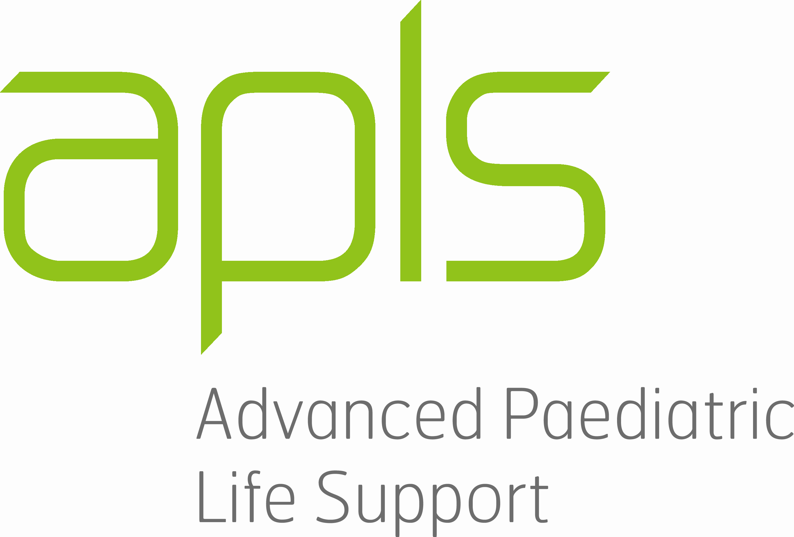

About the Program
The PLS learning environment is dynamic, hands-on and practical, with a single day of scenarios, workshops and skills covering all the basics of emergency management in a paediatric setting.

Key course concepts are introduced during a high quality, pre-course online learning package through APLS. Registered candidates are also provided with a comprehensive APLS manual to assist with their pre-course learning and to review for future reference. Skills are reinforced during the one-day, face- to -face PLS course.

Course Objectives
- To train healthcare personnel to manage paediatric basic life support
- To train healthcare personnel in airway management of paediatric patients
- To train healthcare personnel in cardiac rhythm recognition and defibrillation of the paediatric patient
- To train healthcare personnel to recognise serious injury and serious illness in children
- To increase confidence, awareness, skills and ability to respond to basic paediatric emergencies

Suitable for: Medical, nursing, midwives, paramedics, anaesthetists, radiographers, postgraduates, physiotherapists, occupational therapists, dentists, medical students

Course fees: includes APLS e manual, pre course online learning access and catering (Please circle/tick)
- Internal Northern Health Nursing Staff: (ICU ☐ CCRN ED☐ Ward 2 ☐ GOT ☐ – directorate funded)
- Other Internal NH Staff (Medical & Nursing): $300 per course candidate (Complete ‘Payment Details’)
- External staff: $525 per course candidate (Complete ‘Payment Details’)

2026 Course Dates (please select)
☐ 3rd MARCH 2026
☐ 22nd MAY 2026
☐ 31st AUGUST 2026
☐ 10th NOVEMBER 2026

Additional Course Information: Please contact Kelly Alysandratos (Paediatric Educator/ Course Co Ordinator) Kelly.alysandratos@nh.org.au
All Course registrations: please send electronically to EducationEnquiries@nh.org.au

Registration
Complete this form and return it to EducationEnquiries@nh.org.au by 4 weeks prior to the course after which time, deposits will be forfeited
After this time, you will be emailed to collect the pre reading and register on the APLS website for e learning module.
Study leave does not guarantee a place. An outcome email will be sent to the email address provided on the form.

Applicant Name: Enter here | Employee Number: Enter here
Email address: Enter here | Mobile Number: Enter here
Unit/Department: Enter here

Payment Details:
VISA ☐ | MASTERCARD ☐ |  | CHEQUE ☐
CARD NUMBER |  | AMOUNT: Enter here  Expiry Date: Enter date  CCV number: Enter here
Card holder name: Enter here  Signature: Enter here |  | Date: Enter here

To assist us in planning, please complete the following:
State or Territory Enter here
Primary Place (hospital) of work Enter here
In which Department do you work Enter here
What is your role or grade Enter here
AHPRA registration No. Enter here
Please indicate special dietary requirements Enter here

Terms & Conditions
- All fields must be completed
- No cash payments accepted
- Payments will be processed after the registration closing date
- No refund after the closing date. Credit will be used for future study day.
- Payment will appear on statement as NH Medical Services
- Northern Health will make every attempt to provide the program as outlined, however reserve the right to change or cancel the program.
- Contact EducationEnquiries@nh.org.au or 8468 0751 if you have not received an email within 1 week of sending your registration form
- Study leave needs to be approved by the applicant’s manager and can NOT be processed by Northern Health Education (Study Leave does not guarantee a place)

Forms not filled in correctly or handwritten will be returned

y

