< Study Day Title Here>

**2025 PLS course**

Time: 0745- 1630 hrs

Venue: Northern Centre for Health Education & Research (NCHER)

185 Cooper Street Epping 3076

**One day Accredited Paediatric Life Support Course**

Accrediata

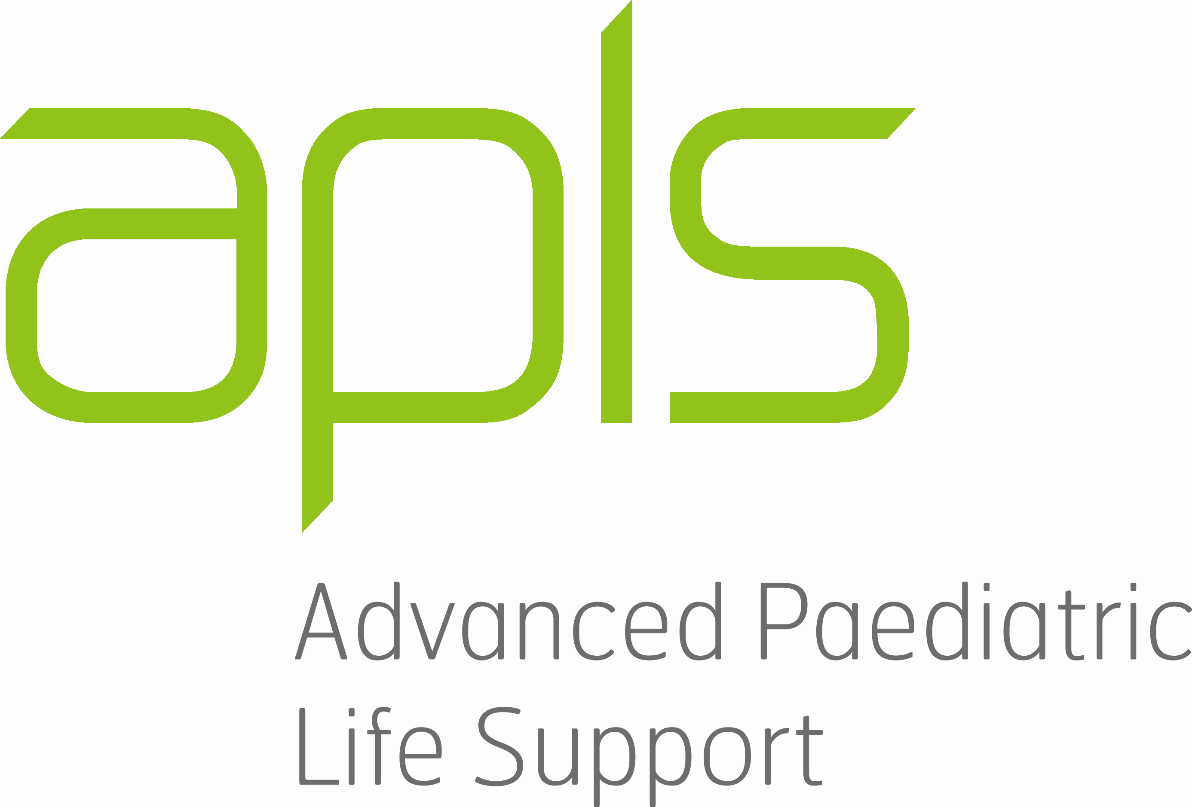

|  |
| --- |
| **About the Program**  The PLS learning environment is dynamic, hands-on and practical, with a single day of scenarios, workshops and skills covering all the basics of emergency management in a paediatric setting.  Key course concepts are introduced during a high quality, mandatory pre-course eLearning package through APLS. Registered candidates are also provided with a comprehensive APLS manual to assist with their pre-course learning and to review for future reference. Skills are reinforced during the one-day, face- to -face PLS course.  **Course Objectives**   * To train healthcare personnel to manage paediatric basic life support * To train healthcare personnel in airway management of paediatric patients * To train healthcare personnel in cardiac rhythm recognition and defibrillation of the paediatric patient * To train healthcare personnel to recognise serious injury and serious illness in children * To increase confidence, awareness, skills and ability to respond to basic paediatric emergencies   **Suitable for:** Medical, nursing, midwives, paramedics, anaesthetists, postgraduates, dentists, medical students  **Course fees:** includes **pre course online learning, course, ebook and catering (Please circle/tick)**   * Internal Northern Health **Nursing** Staff: (ICU  /ED (PG trained only) /Ward 2  /GOT  – directorate funded) * Other Internal NH Staff (**Medical & Nursing):** $300 per course/candidate (Please complete ‘Payment Details’) * External staff: $525 per course candidate (Please complete ‘Payment Details’)   2025 Course Dates (please select)  Tuesday 11th November 2025  **Additional Course Information:** Please contact Kelly Alysandratos (Paediatric Educator/ Course Co Ordinator) [Kelly.alysandratos@nh.org.au](mailto:Kelly.alysandratos@nh.org.au)  **All Course registrations:** please send electronically to [EducationEnquiries@nh.org.au](mailto:EducationEnquiries@nh.org.au) |

|  |  |  |  |  |  |  |  |  |  |  |  |  |  |  |  |  |  |  |  |  |  |  |  |  |  |  |  |  |  |  |  |  |  |  |  |  |  |
| --- | --- | --- | --- | --- | --- | --- | --- | --- | --- | --- | --- | --- | --- | --- | --- | --- | --- | --- | --- | --- | --- | --- | --- | --- | --- | --- | --- | --- | --- | --- | --- | --- | --- | --- | --- | --- | --- |
| **NH Registration**  Complete this form and return it to [EducationEnquiries@nh.org.au](mailto:EducationEnquiries@nh.org.au) by 4 weeks prior to the course after which time, deposits will be forfeited  After this time, you will be emailed for link to register on the APLS website for e learning module.  Study leave does not guarantee a place, please discuss with your manager. An outcome email will be sent to the email address provided on the form.   |  |  | | --- | --- | | **Applicant Name:** Enter here | **Employee Number:** Enter here | | **Email address:** Enter here | **Mobile Number:** Enter here | | **Unit/Department:** Enter here | **Role (Please specify):** Enter here |   **Payment Details:**   |  |  |  |  | | --- | --- | --- | --- | | VISA | MASTERCARD | | CHEQUE | | **CARD NUMBER**   |  |  |  |  |  |  |  |  |  |  |  |  |  |  |  |  |  |  |  | | --- | --- | --- | --- | --- | --- | --- | --- | --- | --- | --- | --- | --- | --- | --- | --- | --- | --- | --- | |  |  |  |  |  |  |  |  |  |  |  |  |  |  |  |  |  |  |  | | | **AMOUNT:** Enter here  **Expiry Date:** Enter date  **CCV number:** Enter here | | | **Card holder name:** Enter here  **Signature:** Enter here | | **Date:**  Enter here | |   **To assist us in planning, please complete the following:**  State or TerritoryEnter here  Primary Place **(**hospital) of work Enter here In which Department do you workEnter here  What is your role or gradeEnter here  AHPRA registration No.Enter here  Please indicate special dietary requirements Enter here  **Terms & Conditions**   * All fields must be completed * No cash payments accepted * Payments will be processed after the registration closing date * No refund after the closing date. Credit will be used for future study day. * Payment will appear on statement as NH Medical Services * Northern Health will make every attempt to provide the program as outlined, however reserve the right to change or cancel the program. * Contact [EducationEnquiries@nh.org.au](mailto:EducationEnquiries@nh.org.au) or **8468 0751** if you have not received an email within 1 week of sending your registration form * Study leave needs to be approved by the applicant’s manager and can NOT be processed by Northern Health Education (Study Leave does not guarantee a place)   **Forms not filled in correctly or handwritten will be returned** |

y